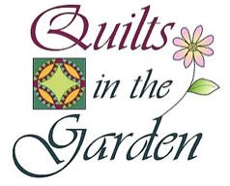

Quilt pieced by:

Quilted by:

Name of Quilt:

Dimensions:

Price (if for sale):

Contact info (if for sale):

Please have form completed on a computer or print clearly and attached to your quilt on the lower right corner with two or more safety pins BEFORE delivering the quilt. If you wrap this form around the edge of the quilt it will also serve as a place to grab if someone is interested in examining the quilt closely or looking at the back. (You may want to put the form in plastic if you are concerned about the ink running on your quilt.)

Your quilt can be for sale if you wish, but the Marys River Quilt Guild will not be involved in the sale of quilts. Potential buyers can contact you directly if you include your phone#. You are expected to give 10% of your sale price back to the Guild.

Thank you for your participation.

